**\*PRODUCT DESIGN THINKING**

**\*QUANTUM UNIVERSITY**

**\*ASS NO.3 (TASK 3)**

**\*Create a stakeholder map**

# **TASK 03**

**Stakeholder Mapping: Rainwater Harvest and Drain Project in Community Apartments**

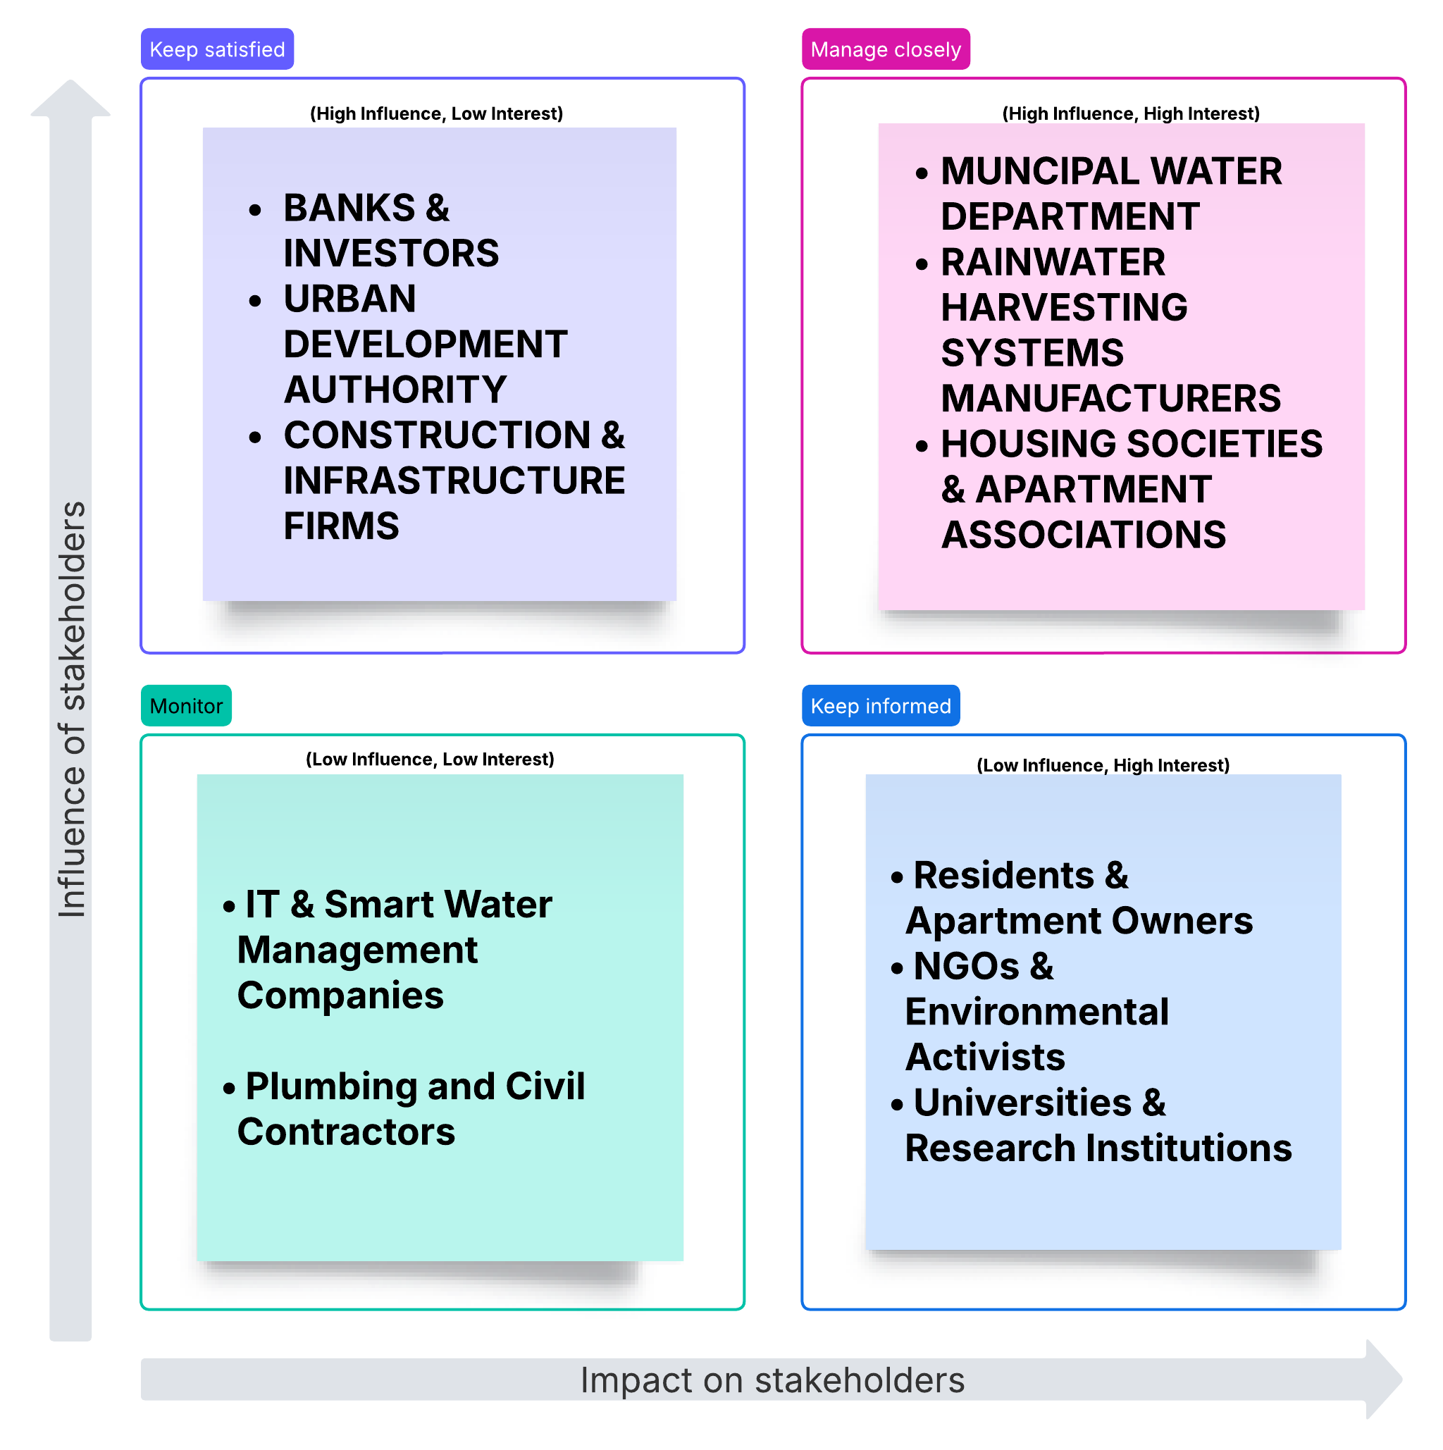

# **Explanation of the stakeholder map:**

### **1. Keep Satisfied (High Influence, Low Interest)**

These stakeholders have significant power in decision-making but may not have a direct or continuous interest in the project. Keeping them satisfied ensures they remain supportive.

* Banks & Investors (Funding is crucial, but they are not involved in daily operations)
* Urban Development Authority (Regulatory approvals are needed, but their engagement is periodic)
* Construction & Infrastructure Firms (They provide essential services but do not manage long-term maintenance)

### **2. Manage Closely (High Influence, High Interest)**

These stakeholders are key players with both strong influence and a vested interest in the success of the project. Their active involvement is necessary.

* Municipal Water Department (Responsible for water regulation and supply management)
* Rainwater Harvesting System Manufacturers (Core suppliers who ensure system functionality)
* Housing Societies & Apartment Associations (Direct beneficiaries and decision-makers in community projects)

### **3. Monitor (Low Influence, Low Interest)**

These stakeholders have limited influence and engagement, but they may become important in the future.

* IT & Smart Water Management Companies (Technological advancements could improve efficiency but are not currently essential)
* Plumbing and Civil Contractors (Execute specific tasks but do not influence long-term policy or strategy)

### **4. Keep Informed (Low Influence, High Interest)**

These stakeholders are highly interested but do not have the power to make key decisions. Keeping them informed fosters community support and advocacy.

* Residents & Apartment Owners (Primary users of the system, benefiting from sustainable water management)
* NGOs & Environmental Activists (Support eco-friendly initiatives and can promote awareness)
* Universities & Research Institutions (Offer insights and innovations for better project execution)